# Project Progress for Group 3

Group Name: Duolingo

Group Members:

1. Cheong Yie Shen Hewitt 103516128
2. Tiong Qi Xuan 103542576

## Project Process Book Progress

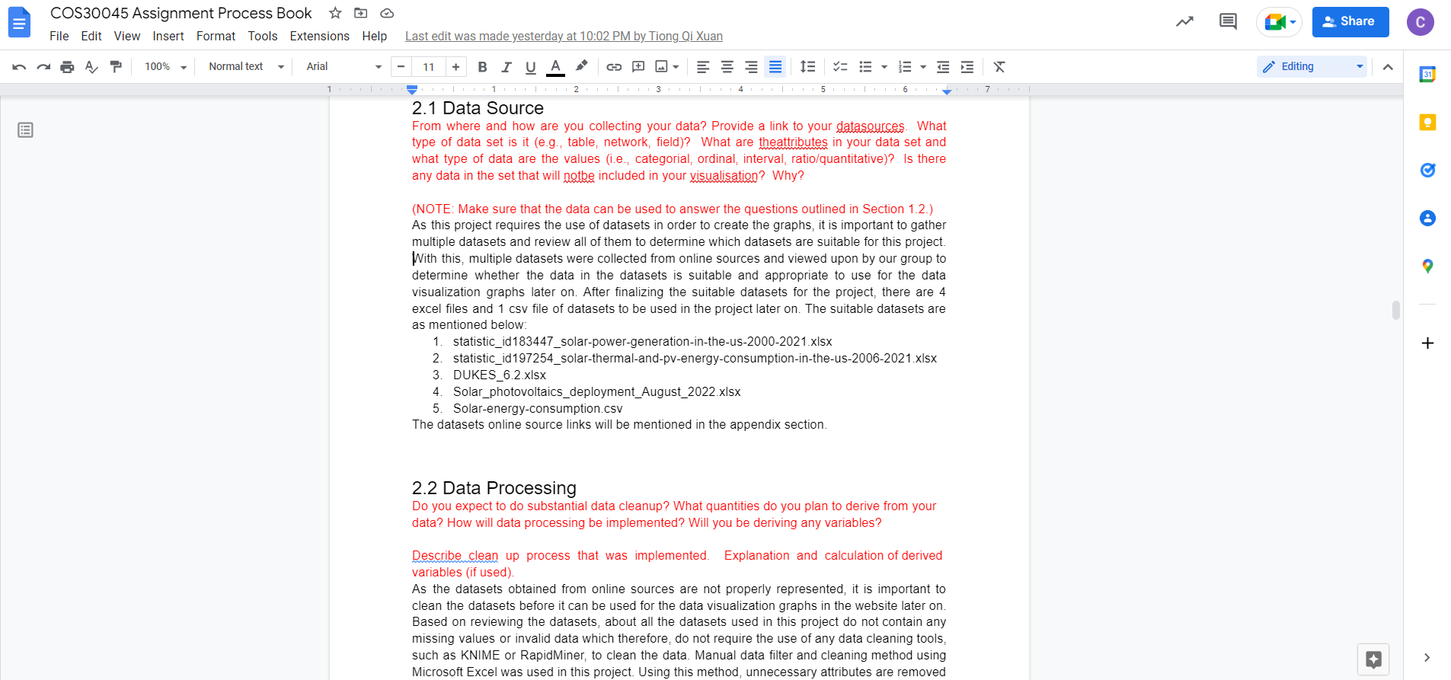

## Cleaned Datasets Screenshots

### United States Cleaned Datasets

***Solar Consumption.csv***

Raw Data:

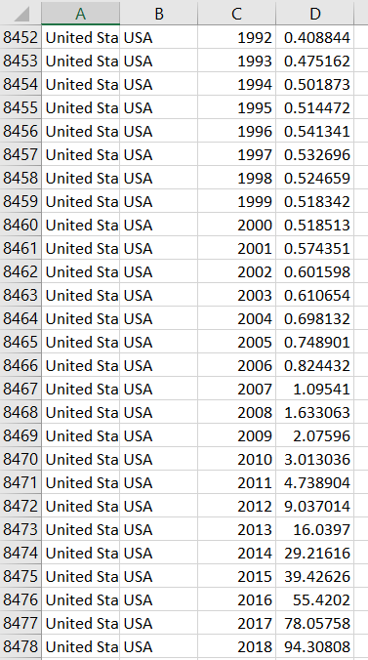

Cleaned Dataset:

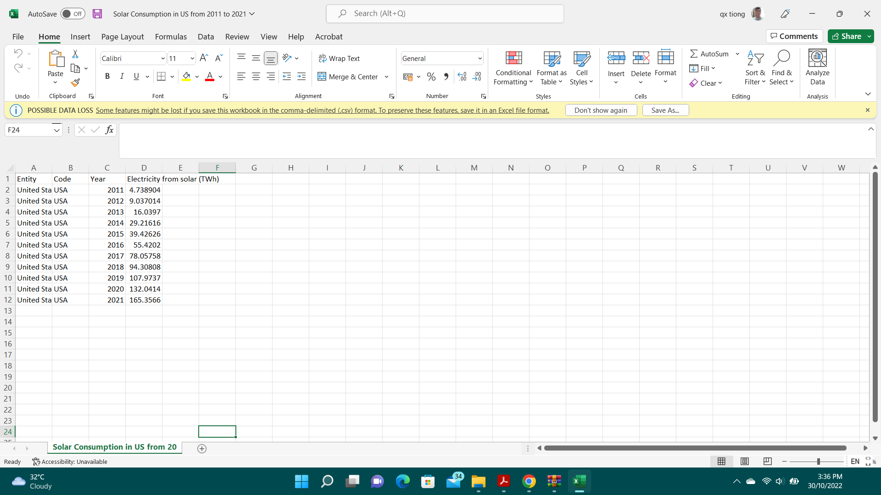

***Statistic_id183447_solar-power-generation-in-the-us-2000-2021.xlsx***

Raw Data:

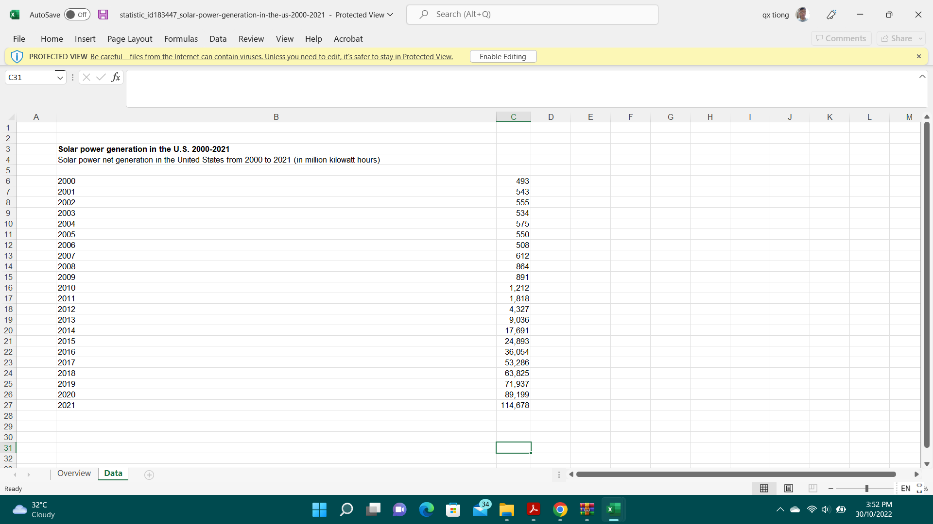

Cleaned Dataset:

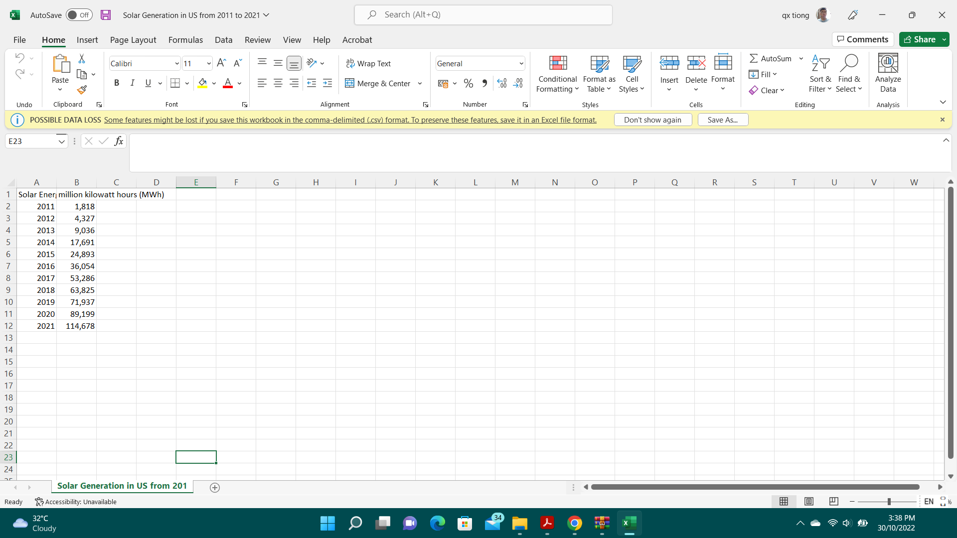

***Statistic_id197254_solar-thermal-and-pv-energy-consumption-in-the-us-2006-2021.xlsx***

Raw Data:

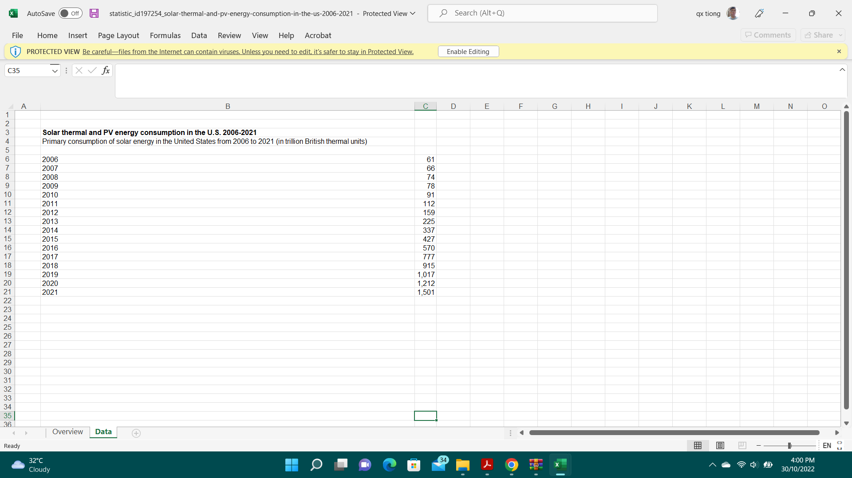

Cleaned Dataset:

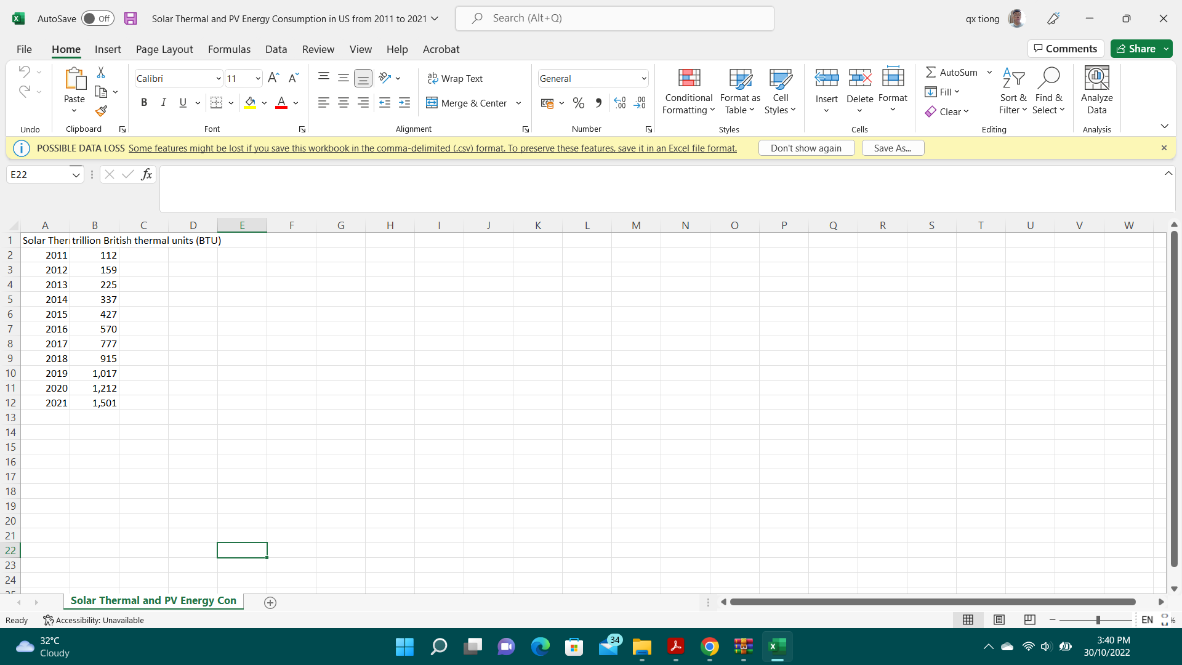

### United Kingdom Cleaned Datasets

***DUKES_6.2.xlsx***

Raw Data:

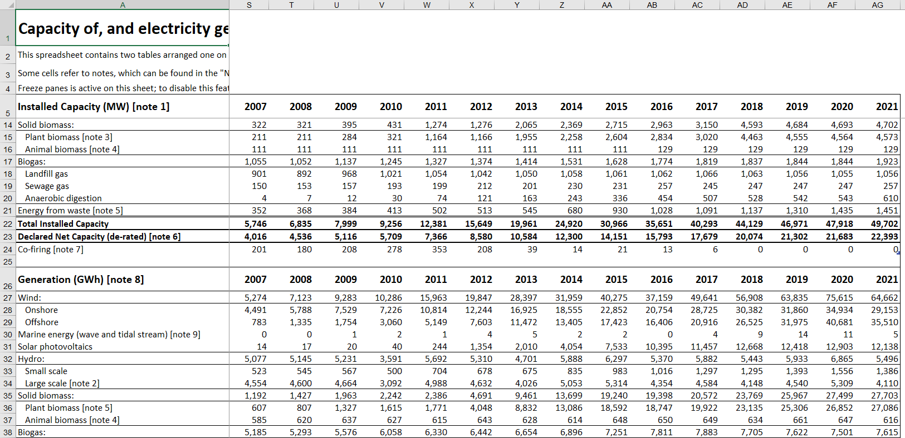

Cleaned Dataset:

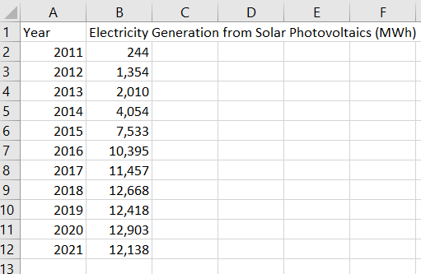

***Solar_photovoltaics_deployment_August_2022.xlsx***

Raw Data:

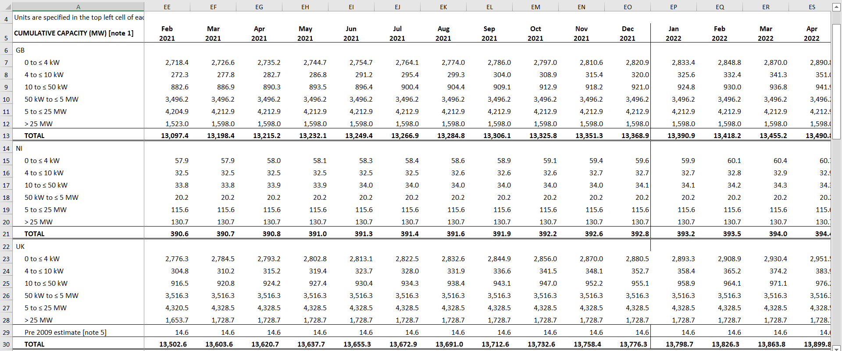

Cleaned Dataset:

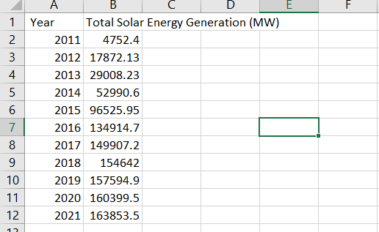

***Solar Consumption.csv***

Raw Data:

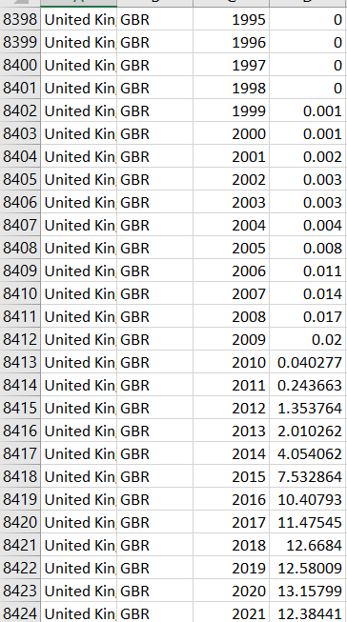

Cleaned Dataset:

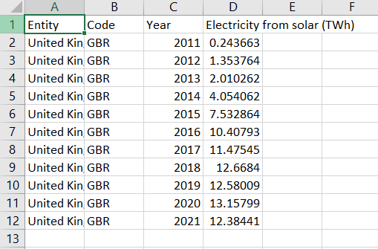

## Data Visualisation Designs

### Line Chart

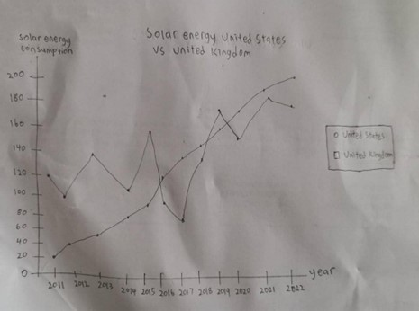

### Circular Bar Chart

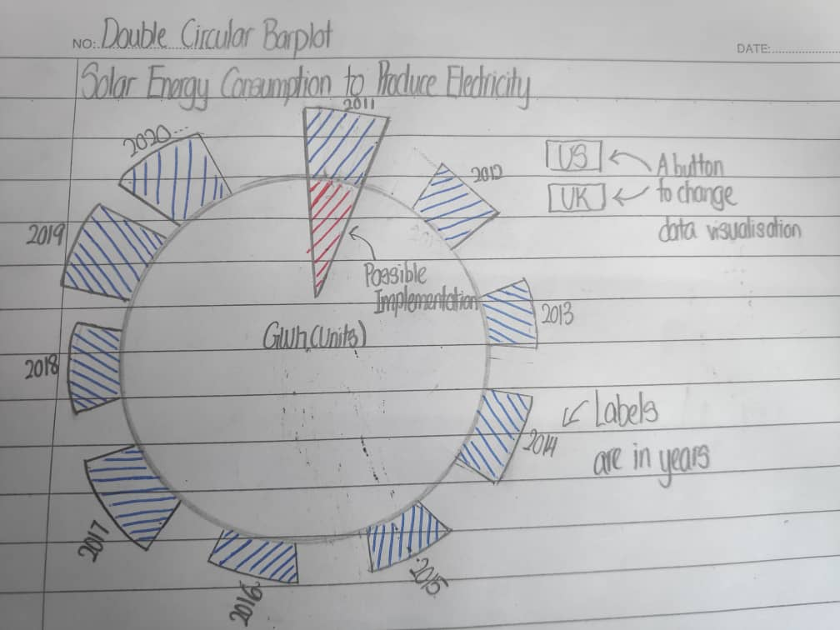

### Bar Chart